Aml Nasser

Amlnasser75@gmail.com

Project Management Plan for Foodies app

Version 1.0

Contents

1. Introduction 3

1.1 Purpose of project management plan 3

1.2 Summary of project charter 3

I. Introduction 3

II. Company’s role and strength. 3

III. Business need 3

IV. Unique Solution 3

V. Timeline 3

VI. Team 4

VII. Conclusion 4

1.3 Assumptions and Constraints 4

I. Assumptions: 4

II. Constraints: 4

1.4 Scope Management 4

1.5 Work Breakdown Structure 5

I. Diagram 5

II. Roles 5

2. Change Control Management 6

3. Schedule / Time Management 6

3.1 Milestones 6

3.2 Project Schedule 6

3.3 Dependencies 7

4. Quality Management 7

5. Configuration Management 7

6. Communication Management 8

I. Communication goals: 8

II. Stockholders' communication: 8

III. Project Teams' communication: 8

6.1 Communication Matrix 9

7. Risk Management 9

7.1 Risk Log 9

8. Issue Management 9

8.1 Issue Log 9

APPENDIX A: REFERENCES 10

APPENDIX B:  KEY TERMS 10

# Introduction

## Purpose of project management plan

The intended audience of the Foodies PMP is all project stakeholders including the project sponsor, senior leadership and the project team.

## Summary of project charter

### Introduction

Our vision: Be Number One choice for our Customer.

Our mission: Make Food Order Easier for every one everywhere.

### Company’s role and strength.

Roles:

Project Manager, Business Analyst, Developers, Tester.

Strength:

Cooperate, Flexible, Self-motivated, Cross-Functional and team-oriented

### Business need

Provides the easiest way to order food 24 hours per week, the fastest delivery, and also the app provides food offers.

### Unique Solution

Our website tries to be different as the customer actually finds a user-friendly interface with the highest performance possible to satisfy the customer.

Suggesting all available nearby restaurants.

Users reserve Loyalty Points as much as they use Restaurants through our app.

### Timeline

We plan to provide Five milestones for the project and define the project as ready for publishing within 5 weeks of working as it needs approximately 212.5 hours. (5 Engineers each work daily for 2 hours 85% Capacity)

### Team

Our team consists of 5 members as follow:

1. Aml Nasser: project & configuration manager
2. Hagar Hany: Team Leader, Developer
3. Marina Hatem: Developer and Tester
4. Noura Amr: Developer and Tester
5. Hagar El-Sayed: Developer and Tester

### Conclusion

This project will provide the needed luxury for user and provide the customer with the needed functionality to achieve the highest market value (profit).

## Assumptions and Constraints

### Assumptions:

* We need a Log in Page
* We need a Tracking Order Page

### Constraints:

* Web based System / PC based
* Unique user IDs
* Admin features needed

## Scope Management

External Change Management Plan File.

## Work Breakdown Structure

## Diagram

## Roles

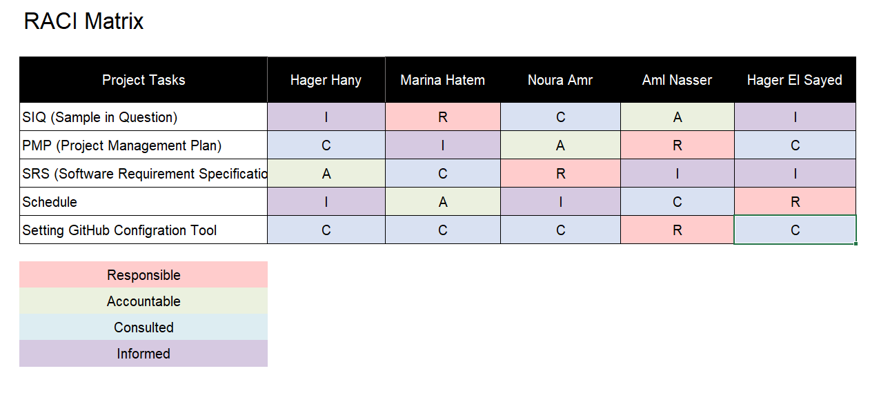

# Change Control Management

External Change Management Plan File (deferred).

# Schedule / Time Management

## Milestones

| **Milestones** | **Estimated Completion Timeframe** |
| --- | --- |
| - Sample in Question (SIQ)  - Software Requirements Specification (SRS)  -Project Management Plan (PMP)  -Configuration Management Tool setup  -Project Schedule  -Finish User Acceptance Testing | * First Week |
| TBD | * Second week |
| TBD | * Third week |
| TBD | * Fourth week |
| TBD | * Fifth week |

## Project Schedule

External Project Schedule File

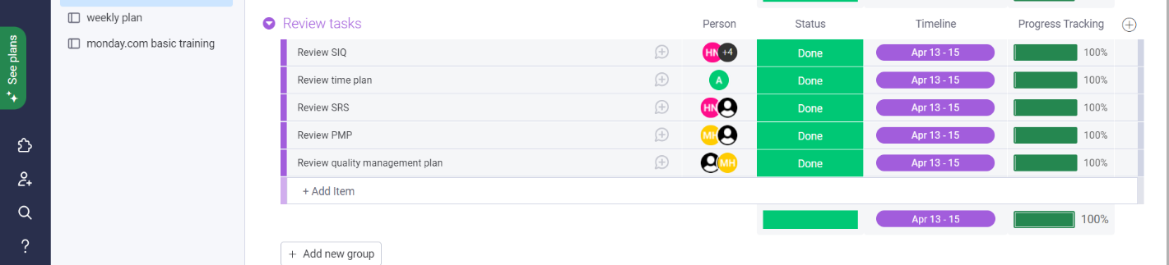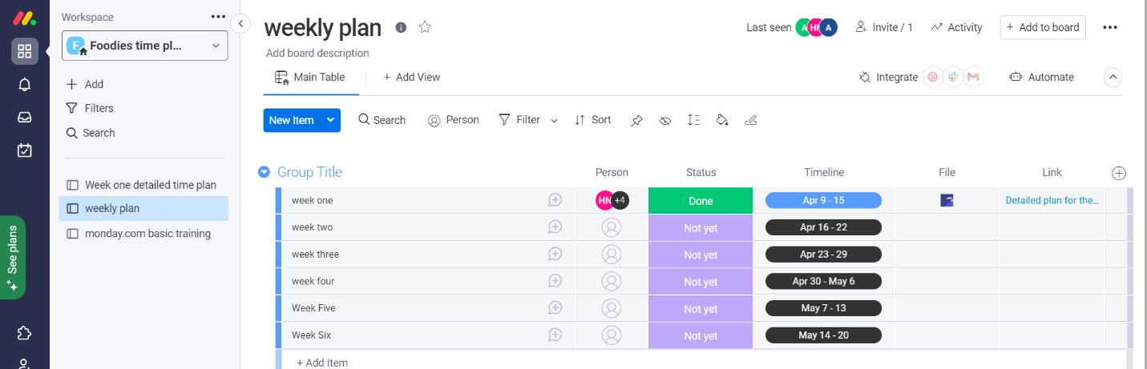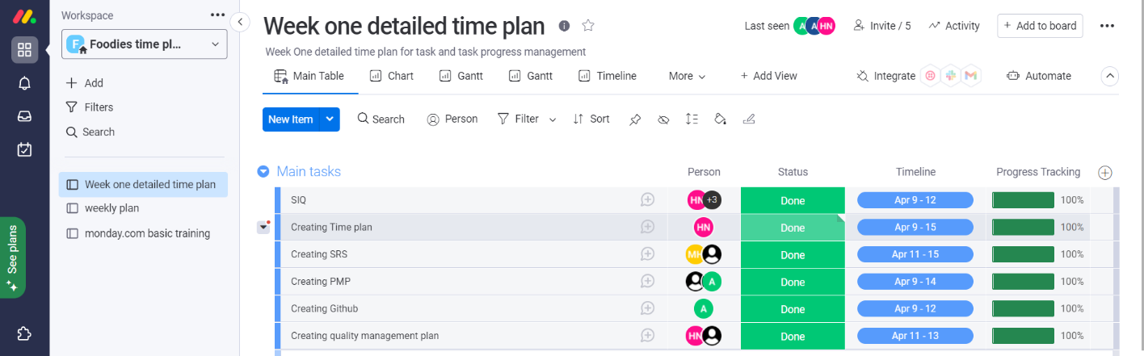

## Dependencies

We are following the Waterfall Model of SDLC

Each Step depends on the previous step (Finish to Start)

To Start Testing Must Finish Development

To Start Testing Must Finish Development

To Start Development Must Finish Design

To Start Design Must Finish Analysis

To Start Analysis Must Finish Requirement

# Quality Management

External Quality Management File

# Configuration Management

We tailored our Configuration Management tool to use Git and GitHub instead of Tortoise SVN.

We will track all our Documents, Code, Testing, Monitor & Control phases through the software life cycle(SDLC).

The guidelines on how we will use the CM:

There are two branches:

The first one is for the baseline

The other one is for the internal changes between the releases.

Pull requests are required for the master branch only

Tags will be used to distinguish between baselines.

Tags must be in this format (DayMonthYear-Inter/Release-no of release)

ex: 160422-Release-01

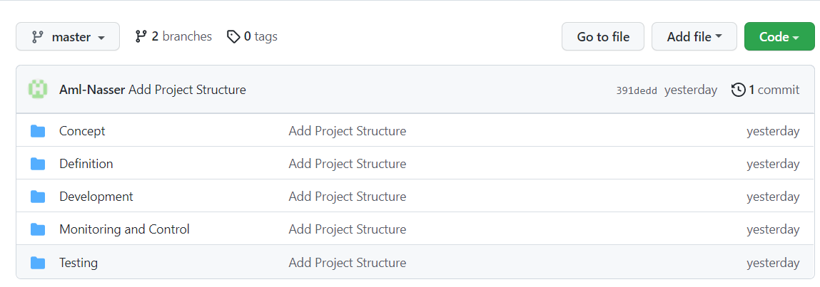

# Communication Management

Communication plan: Foodies

### Communication goals:

-keep the stakeholder informed with all new updates and all the project needs

-Provide clear insight into any decisions needed or roadblocks

-Provide structured opportunities for feedback from stockholder

### Stockholders' communication:

-We are going to use formal mails to communicate and clarify some points in addition to the meetings whether it's an online or offline so as to take their feedback on the work and if they want to introduce any changes or suggestions

### Project Teams' communication:

-We are going to use formal mails to communicate and clarify some points in addition to the meetings whether it's an online or Face-to-face so as that we can discuss all what we have and take each other opinions

-Also, we can use some social media apps as slack or what's app or Trello for easier and faster communication

## Communication Matrix

# Risk Management

External Risk Management File

## Risk Log

External Risk Log File

# Issue Management and Escalation

External issue Management File

## Issue Log

External issue Management File

# 

# APPENDIX A: REFERENCES

The following table summarizes the documents referenced in this document.

|  |  |  |
| --- | --- | --- |
| **Document Name and Version** | **Description** | **Location** |
| Change Management Plan  1.0 | Describe [change control](https://www.stakeholdermap.com/project-dictionary/project-dictionary-c.html#change-control) policies and procedures and how [change control](https://www.stakeholdermap.com/project-dictionary/project-dictionary-c.html#change-control) will interface with other aspects of [project management](https://www.stakeholdermap.com/project-dictionary/project-dictionary-p.html#project-management-pm). | *deferred* |
| External Project Schedule File  1.0 | Describe the roadmap of the project | [*https://hagar-nassar.monday.com/boards/2536007828*](https://hagar-nassar.monday.com/boards/2536007828) |
| Scope Management  1.0 | Describe Scope of the project | [*https://github.com/Aml-Nasser/Foodies/blob/master/Concept/Scope%20Statement.docx*](https://github.com/Aml-Nasser/Foodies/blob/master/Concept/Scope%20Statement.docx) |
| External Quality Management File  1.0 | Identifying the quality requirements and standards for the project and product. | [*https://github.com/Aml-Nasser/Foodies/blob/master/Monitoring%20and%20Control/Quality%20Management%20Plan.doc*](https://github.com/Aml-Nasser/Foodies/blob/master/Monitoring%20and%20Control/Quality%20Management%20Plan.doc) |
| External Risk Management File  1.0 | Contain Probable Risk with risk Impact and Probability of Occurrence | *Log:*  [*https://github.com/Aml-Nasser/Foodies/blob/master/Monitoring%20and%20Control/Risk_Management_Log.xlsx*](https://github.com/Aml-Nasser/Foodies/blob/master/Monitoring%20and%20Control/Risk_Management_Log.xlsx)  *Plan:*  [*https://github.com/Aml-Nasser/Foodies/blob/master/Monitoring%20and%20Control/Risk%20Management%20Plan.doc*](https://github.com/Aml-Nasser/Foodies/blob/master/Monitoring%20and%20Control/Risk%20Management%20Plan.doc) |
| External Issue Management File  1.0 | Identifying track and resolve project issues throughout the life of the project ensuring effective communication | [*https://github.com/Aml-Nasser/Foodies/blob/master/Monitoring%20and%20Control/Issue%20Management%20and%20Escalation%20Plan.docx*](https://github.com/Aml-Nasser/Foodies/blob/master/Monitoring%20and%20Control/Issue%20Management%20and%20Escalation%20Plan.docx) |

# 

# APPENDIX B:  KEY TERMS

The following table provides definitions for terms relevant to this document.

|  |  |
| --- | --- |
| **Term** | **Definition** |
| Communication | The effective sending and receiving of information. Ideally, the information received should match the information sent. It is the responsibility of the sender to ensure this takes place. |
| Stakeholder | Individuals or groups involved in the project or whose interests may be affected by the project’s execution or outcome. |
| Communications Management Plan | Portion of the overall Project Management Plan which details how project communications will be conducted, who will participate in communications, frequency of communications, and methods of communications. |
| SDLC | Software Development Life Cycle. |
| TBD | To Be Determined. |